**TDS & TDP Installation Implementation**

**TDS & TDP (8.0.1)**

**Installation Guide & Documentation**

Contents

Section 1: Introduction ……………………………………..3

Section 2: Prerequisites……………………………………..4

Section 3: Installation………………………………………..4

Section 4: Configuration…………………………………….9

Approval

| Signatures by each signatory indicate their acceptance that this document is complete and accurate to the best of his/her knowledge per responsibilities outlined in this document and as guided by approved methodologies and established procedures. | | |
| --- | --- | --- |
| Talend Lead:  Artha Emp | **Subhransu** | **Date:** |
| Project Manager:  Artha Emp | **Pavan Valluri** | **Date:** |
| Talend Developer:  Artha Emp | **Omkar** | **Date:** |

# **Section 1: Introduction**

**Talend Data preparation**

Talend Data Preparation is a self-service application that enables information workers to cut hours out of their workday by simplifying and expediting the laborious and time-consuming process of preparing data for analysis or other data-driven tasks. Talend Data Preparation runs on top of the Talend Integration Platform and delivers enterprise-class capabilities together with connectivity to virtually any data source. It fosters collaboration between business people who know the data best and central organizations, like IT or Risk Management, that define the rules and policies for data accessibility and governance.

It includes:

* Integration and cataloging.
* Data Discovery and Profiling.
* Cleansing, standardizing and shaping.
* Enriching and connecting datasets.
* Operationalizing Data Preparation.

**Talend Data Stewardship**

Data stewardship is the practice of ensuring an organization’s data is accessible, trustworthy, usable, and secure. It oversees every stage of the data lifecycle: creating, preparing, using, storing, archiving, and deleting duplicates, in accordance with an organization’s established data governance principles for promoting data quality and health.

**Data stewardship encompasses:**

* Knowing and documenting what types of data an organization possesses (and the quality of the data)
* Understanding where data assets are located and monitoring the use of data.
* Ensuring high-quality data is accessible, usable, safe, and trusted — quickly identifying data quality issues.
* Enforcing data policies, business rules, and initiatives around how a company’s data can be used.
* Helping the organization make most of its business data for competitive advantage.
* Ensuring stakeholders, data owners, and business users create a data-driven culture.

**Installation Environment**

DEV Environment

# **Section 2: Prerequisites**

**Download & Configure Java**

cd /usr/lib

mkdir jvm

Give full permission to jvm folder

wget https://www.oracle.com/in/java/technologies/javase/jdk11-archive-downloads.html#license-lightbox

(or)

#Download the file from:- https://bell-sw.com/pages/downloads/

#Extract the java file

tar -xvf jdk-11.0.17-linux-x64.tar.gz

#set the java path

export JAVA_HOME=/usr/lib/jvm/jdk-11.0.18

export PATH=$JAVA_HOME/bin:$JRE_HOME/bin:$PATH

#reboot or restart the server to check java version

java –version

# **Section 3: Installations**

Step 1:-Login to Talend Cloud.

URL:- https://login.ap.cloud.talend.com/

Region:- Asia Pacific on AWS

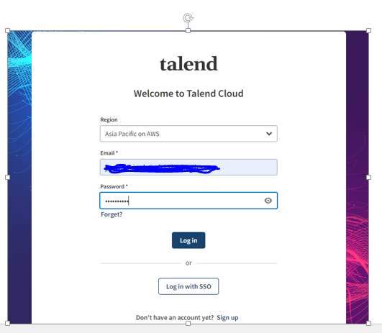

Download the Linux installer for TDS and TDP

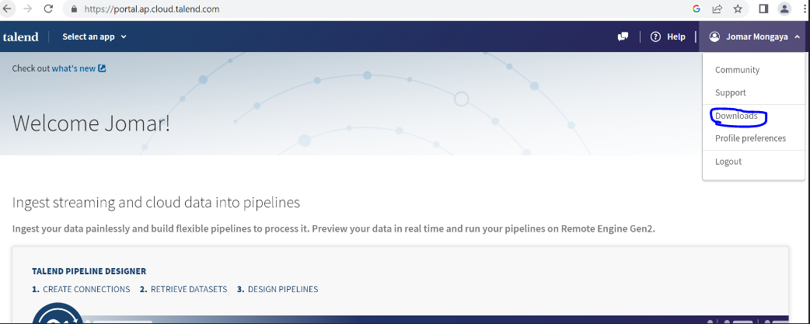

#check the Data stewardship and Data preparation.

#change the type

i) Installer for Linux (run)

#Click on download and download the TDP & TDS .run file

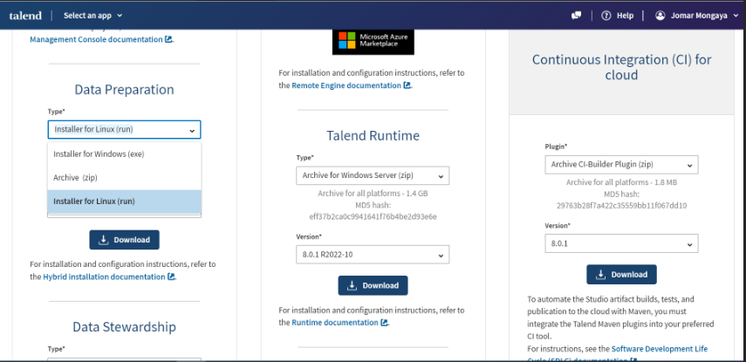

#Check the zip file has been downloaded

Talend-Hybrid-20221107_0900-V8.0.1-R2022-11-linux-installer.zip

#copy this .zip file to the Linux server using WinSCP.

Enter the below command in the Linux terminal.

mkdir Talendfiles

#Copy the .zip file into directory.

cp Talend-Hybrid-20221107_0900-V8.0.1-R2022- 11-linux-installer.zip /opt/Talend files.

yum install unzip

unzip Talend-Hybrid-20221107_0900-V8.0.1-R2022-11-linux-installer.zip

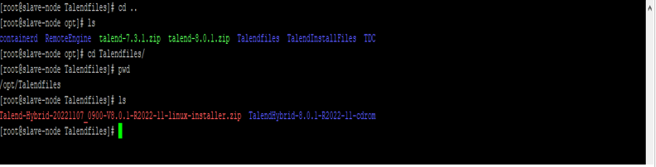

# **Section 4: Configuration**

cd /opt/Talendfiles/ TalendHybrid-8.0.1-R2022-11-cdrom

./TalendHybrid-20221107_0900-V8.0.1-R2022-11-linux64-x64-installer.run

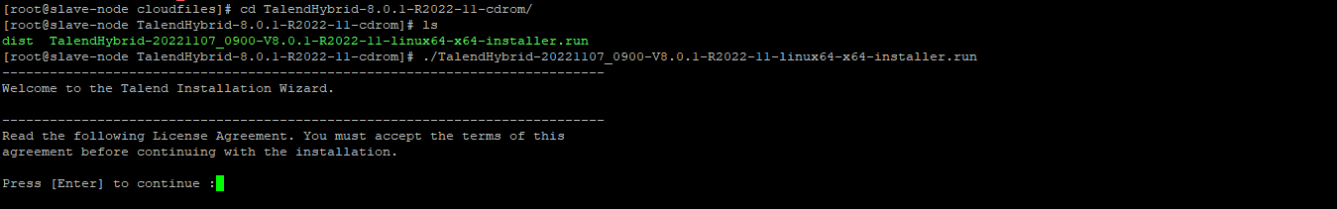

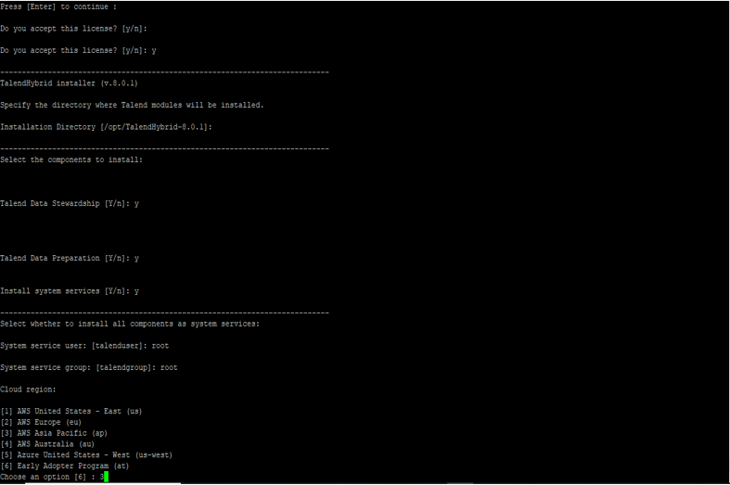

# Goto Talend cloud login

i) Click on user.

ii) Profile preferences

iii) Personal Access token

Generate the new token (or) Take the name of generated token.

Personal Access Token []: <Access token

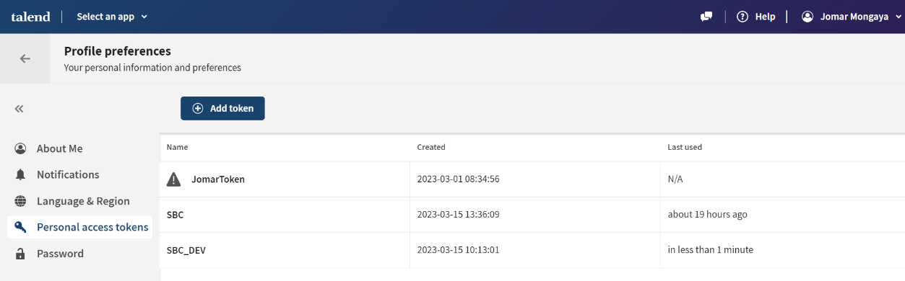

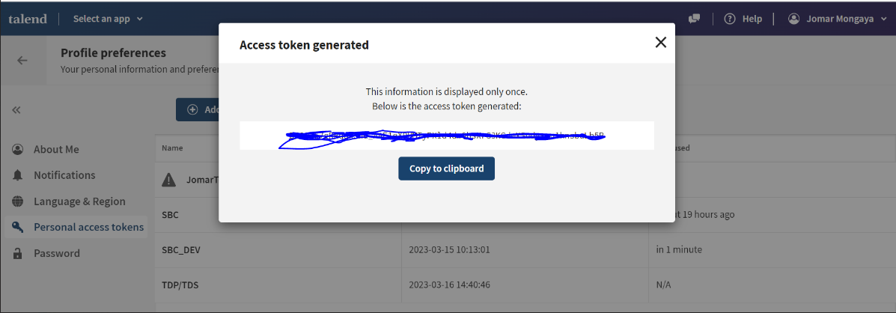

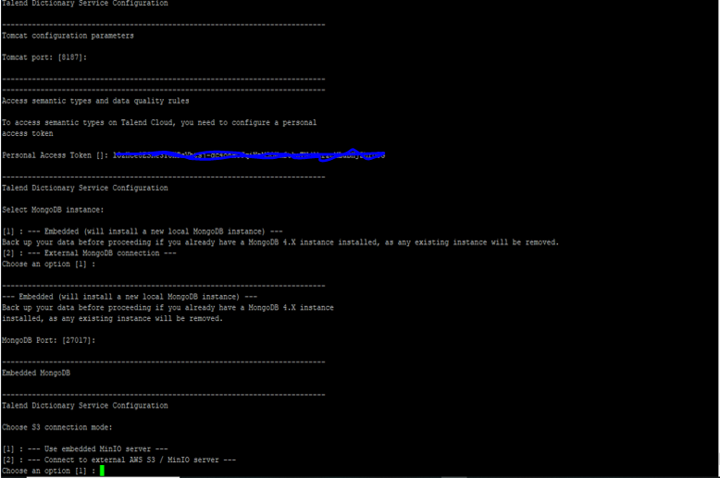

#Generate the client ID and Client Secret on Talend cloud for Data stewardship

1. Select an app
2. Talend management console
3. Configuration
4. Data stewardship
5. Edit URL and give the ip address
6. Generate

Copy and paste the client ID and client secret

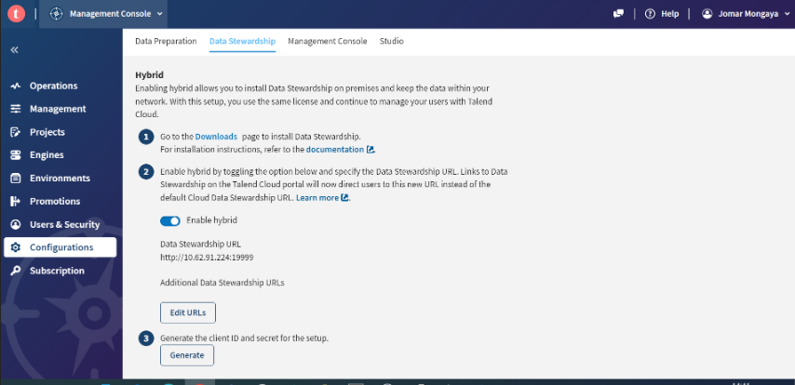

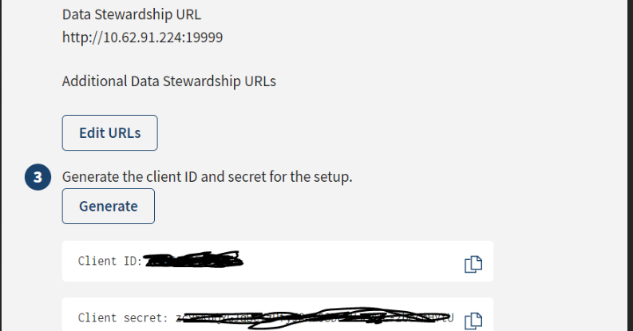

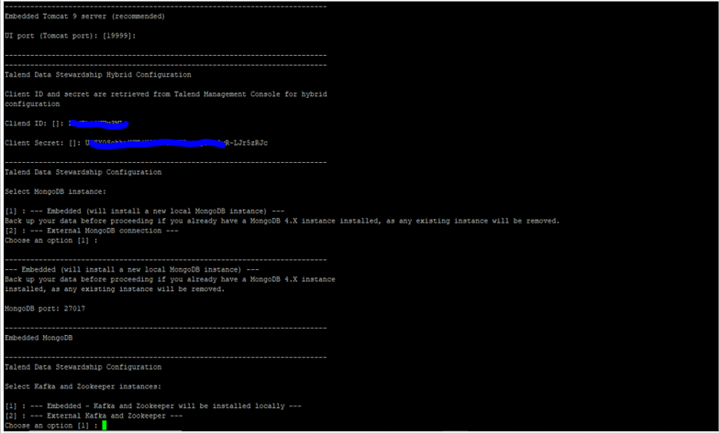

Generate the client ID and Client Secret on Talend cloud for Data prepration

1. Select an app
2. Talend management console
3. Configuration
4. Data stewardship
5. Edit url and give the ip address
6. Generate

Copy and paste the client ID and client secret

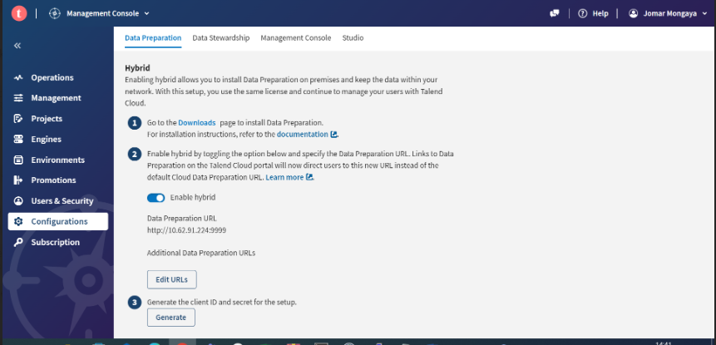

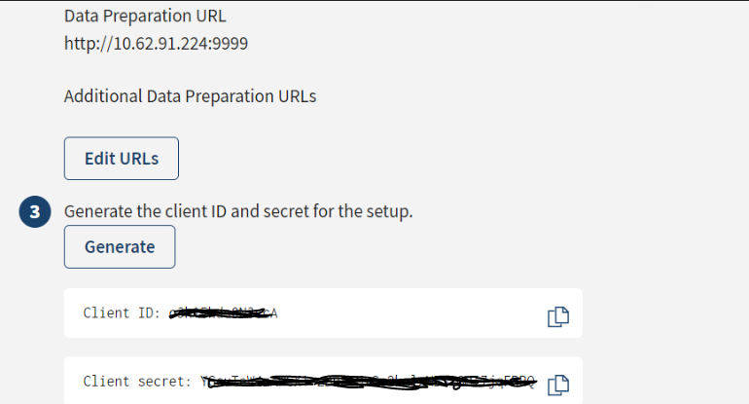

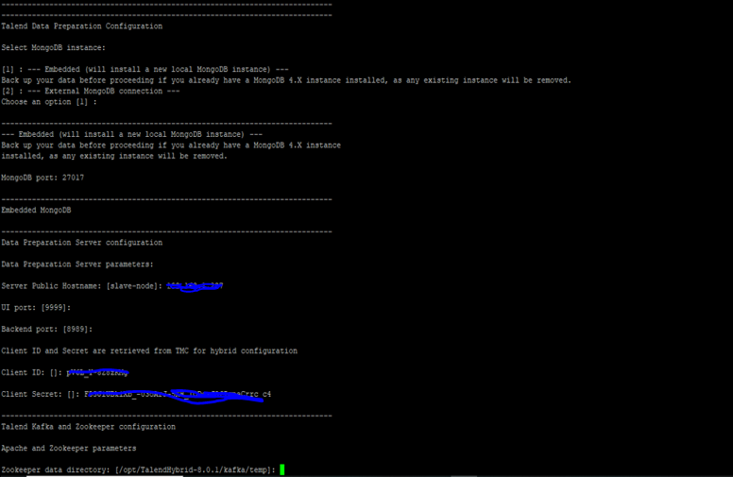

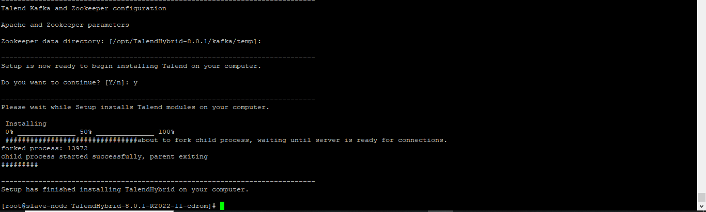

**Data Prep URL**

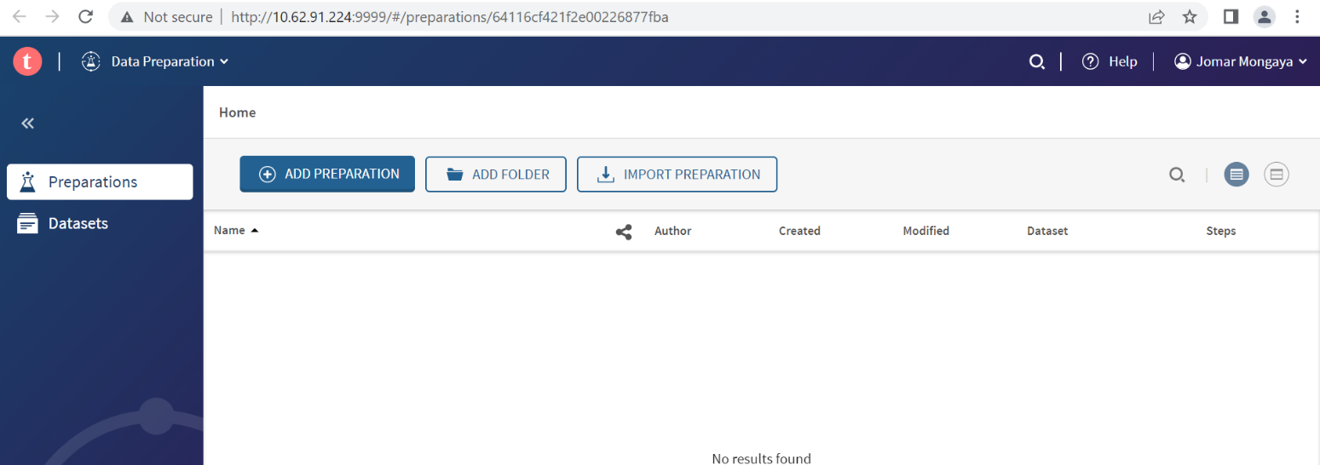

**Data Stewardship URL**

